Finding the safest area for the new house in Montgomery County, MD

Final project - Dss 665 - R progamming

student: Darko Stankovic

2018

Introduction

The idea for this project came out of a conversation between me and my girlfriend regarding our plans to purchase a house. We both agreed upon priorities and concluded that determining factor in our decision-making process will be safety of the area. Taking into account that we have to commute to Washington DC every day for our jobs, I decided to start this project and visually present the safest location in Montgomery County.

I started the project by collecting data from the website [Data.gov](https://catalog.data.gov/dataset/crime). I derived my data set from reported crimes classified according to the National Incident-Based Reporting System (NIBRS) of the Criminal Justice Information Services (CJIS) Division Uniform Crime Reporting (UCR) Program and documented by approved police incident reports in the Montgomery County, Maryland. The information contained herein includes all founded crimes reported after July 1st, 2016.

The project is delivered using R Programming version 3.5.1.

For this project I have selected the following libraries:

1. library(tidyverse) - is the package that load all four libraries:

1.1. library(readr)

1.2. library(tidyr)

1.3. library(dplyr)

1.4. library(ggplot2)

2. library(ggmap) - is the package to pull the real-time roadmaps from GoogleMaps

3. library(caTools) - running easy statistics on the data

4. library(ggthemes) - additional themes, scales and geoms for the ggplot2

Loading Data

To load my data, I have used the simple command " file.choose()" a select my Crime.csv dataset. The first seven rows of the data show that my dataset contains a different type of data.

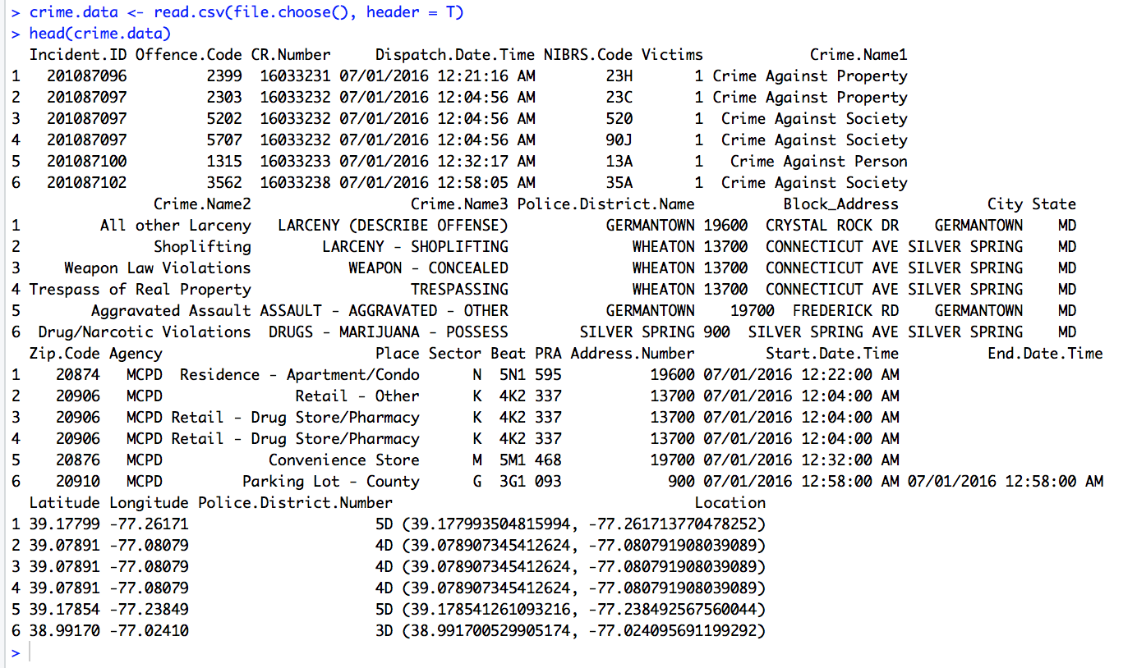

To find how many variables, what type of data and how big is my dataset I am running glimpse() function on my data.

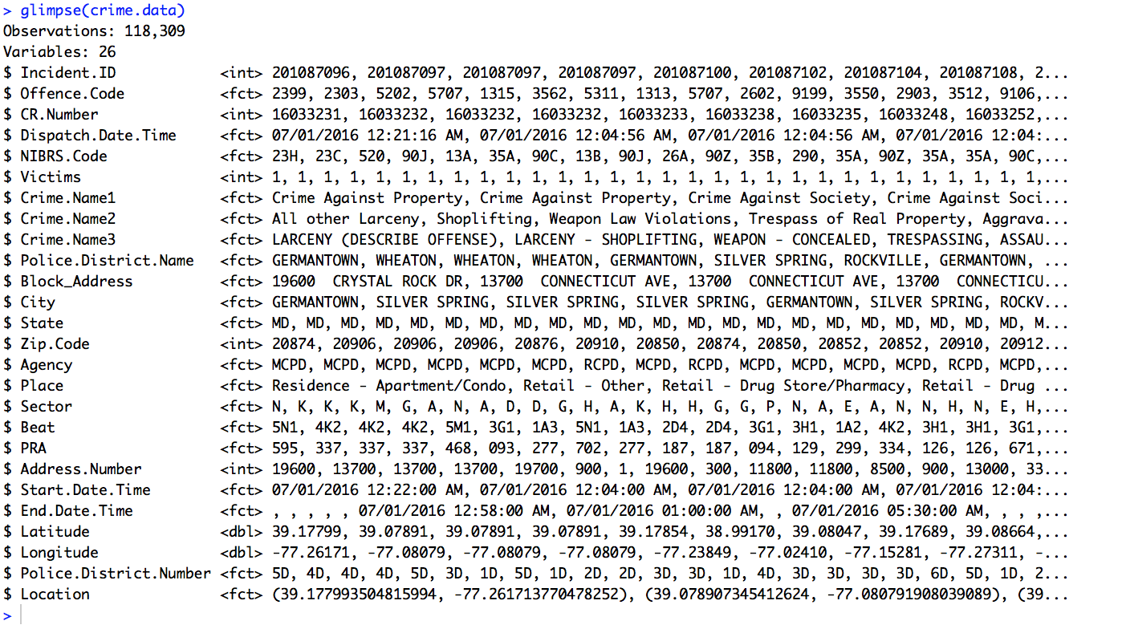

From the given output I can see that my dataset has 26 variables and 118,309 observations (has 4550 rows of data). The majority of my data has a factor data type.

I can see that some of the variables are repeated, and I will choose only variables that will have importance for my project.

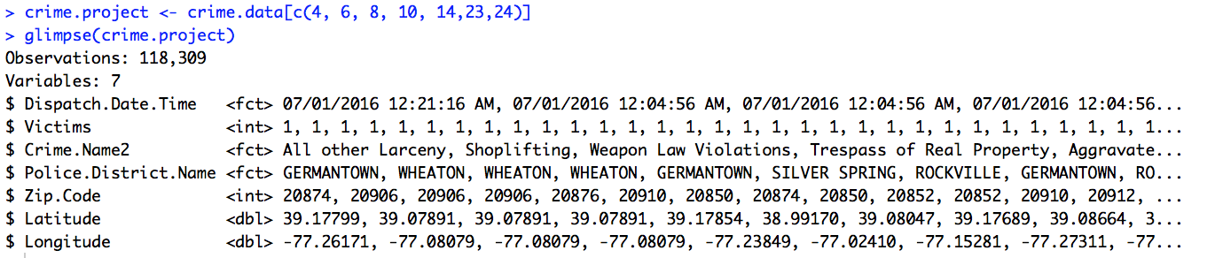

Now when I have my data set ready, I can continue the project and start the visualizations of my data.

Visualization

My visualization starts with finding the coordinates for the area of interest and pulling the map from Google Maps. Montgomery County in Maryland has Longitude = -77.24052 and Latitude = 39.15474. My zoom parameter for this map is set to 10.

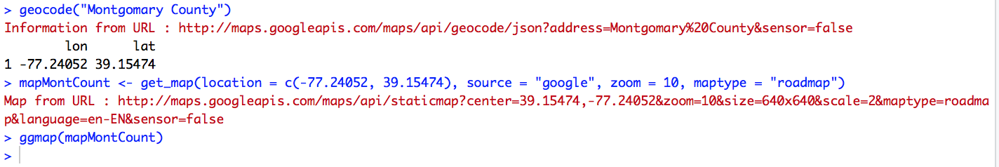



Montgomery County by Google Maps

Now when I have my map, I am going to check what type of crimes I have in my dataset by putting all data into a table. The data is organized from the most repeated offense to the least repetitive offense. Following the crime table, I plugged all crimes on the Montgomery County map.

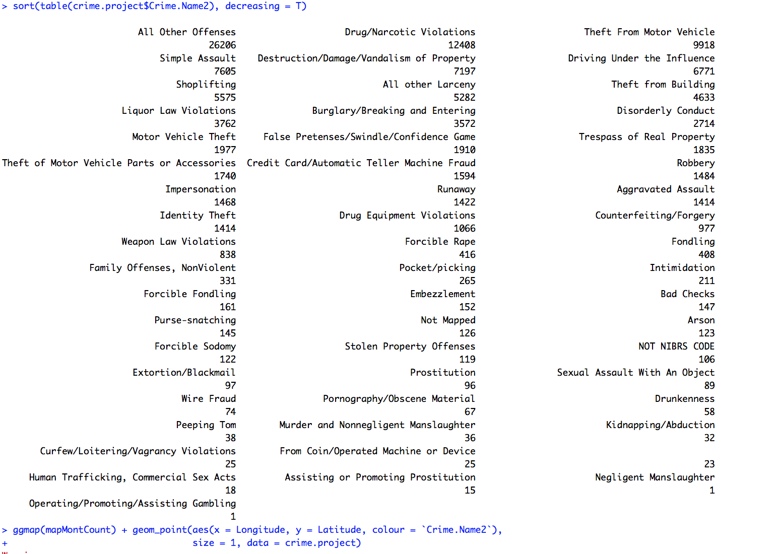

All crimes committed in MC after July 1st, 2016

Conclusion after this map is that I have a lot of data and a lot of different crimes.

To better present data and achieve desired outcome I am limiting crimes data to four crimes:

1. Drug/Narcotic Violations
2. Destruction/ Damage/ Vandalism of Property
3. Burglary / Breaking and Entering
4. Robbery.

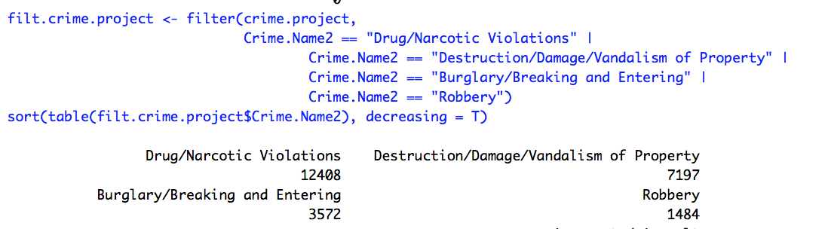

The rest of the data will remain "zero" in the further analysis. Going back to the map and add only filtered crimes.



Filtered crimes committed in MC after July 1st, 2016

I can see on the map that there are some areas where the crime level is on the high level and also some areas where crime level is not that high.

Using our dataset, I am looking for the city that is going to be our possible choice.

Sorting crime in the table I can see that Takoma Park is the area with only 73 committed crimes. Comparing to Silver Spring with 5874 crimes or Wheaton with 5174 committed crimes, Takoma Park has a much lower crime rate.

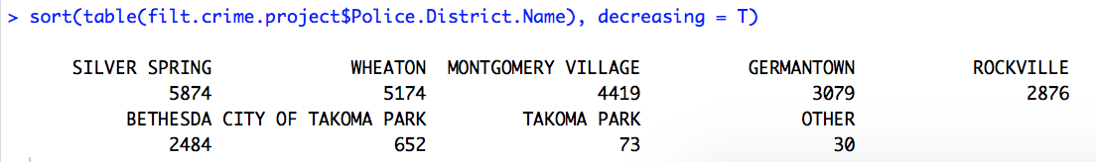

Double checking the data by making bar plots to confirm that Takoma Park is the right choice.

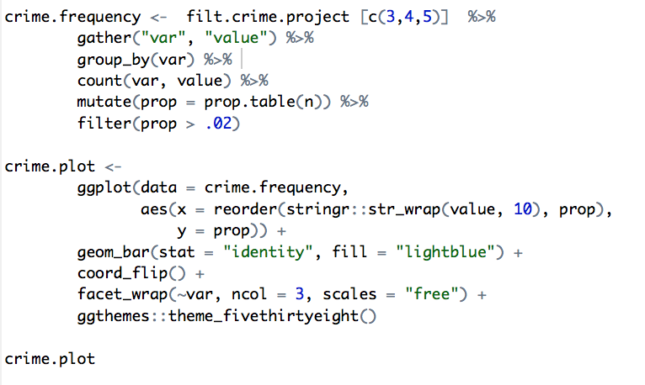



Bar presentation of the crime rate for different variable

Bar presentation confirmed that Takoma Park is for now the best possible choice. I will perform the data visualization to check the area.

Takoma Park Visualization

First, I found the Longitude and Latitude for Takoma Park area. Next, I imported the crime data in the Takoma Park Google Map to help me visualize the data. The zoom for the map is set to 15 so that I can have a closer look to data.

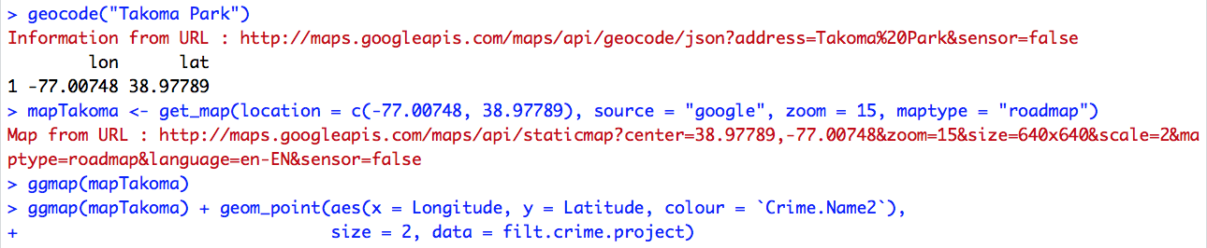



Filtered crimes committed in Takoma Park after July 1st, 2016

Get back to my girlfriend with the explanation what this visualization presents, and her first comment was that this area looks like "Crime on every corner". Looking at the map, it seems like that the crime is happening on almost every corner.

From here I decided to go back to the original Montgomery County Crime map and try to find the spot on the map that is "clean" but also not too far from the urban city areas.



Filtered crimes committed in MC after July 1st, 2016

Looking at the map, I decided to check the red circled area because it seems like a part that does not have a lot of dots (crimes). Also, this is close to the urban city area which is one of the priorities in our choice.

Montgomery County crime on the zoomed map

Changing zoom to 13 allows me to have a better view of this area after I insert the crime data.

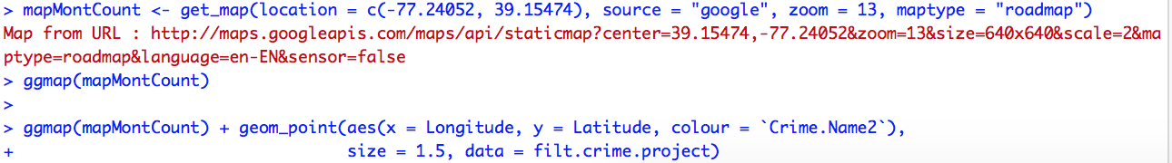



Filtered crimes committed in part of MC after July 1st, 2016

On the first look, this area looks like place that has high crime volume. I decided to go into the more in-depth visual analysis and see the density of the crime in the area.

Density of all crime in the chosen area will show me the concertation of the crime.





Density of the Filtered crimes after July 1st, 2016

The density presentation looks a little bit messy, but I can see that small town called Kentlands has a much lower density of the crime compared to the rest of the map.

Splitting the map for each crime

My next goal is to split the map for every crime and check the density of the crime in the area for every crime separately.





Split map for each crime after July 1st, 2016

Density for the map by crime shows us that the area around Kentlands has almost no Robbery crime and very low Drug / Narcotic Violations. The Destruction / Damage / Vandalism of Property and Burglary in Kentlands has much lower density comparing to the rest of the urban area of the map.



Split map for each crime density after July 1st, 2016

Kentlands Visualization

I plugged the crime data into Kentlands area for the visual comparison with Takoma Park. Note that I am using the same zoom = 15 for the map view as I did in Takoma Park.

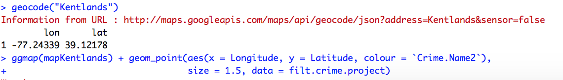



Filtered crimes committed in Kentlands after July 1st, 2016

Conclusion

My girlfriend looked at the map and loved the fact that the area has almost everything that we wanted. It has an elementary school, shopping center, small lakes around perfect for a morning run and the most important it has low crime frequency.

We made our decision.

We are going to contact our real estate agent and let him know that our wish is to look for the hour in the Kentlands, MD.

This project shows that R programming is an powerful language with a very broad usage in the real world problems.